**SPRINT 1**

|  |  |
| --- | --- |
| Date | 03 November 2022 |
| Team ID | PNT2022TMID40580 |
| Project Name | DETECTING PARKINSON’S DISEASE USING  MACHINE LEARNING |
| Maximum Marks | 4 Marks |

1. Make necessary imports:

* import numpy as np
* import pandas as pd
* import os, sys
* from sklearn.preprocessing import MinMaxScaler
* from xgboost import XGBClassifier
* from sklearn.model_selection import train_test_split
* from sklearn.metrics import accuracy_score

**Screenshot:**

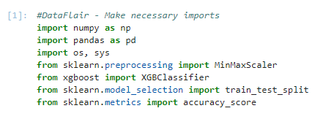

1. Now, let’s read the data into a DataFrame and get the first 5 records.

* #DataFlair - Read the data
* df=pd.read_csv('D:\\DataFlair\\parkinsons.data')
* df.head()

**Output Screenshot:**

